21. HALF ADDER

EXP.NO: 21

AIM: To design and implement the two bit half adder using Logisim simulator.

PROCEDURE:

1)      Pick and place the necessary gates.

2)      Insert 2 inputs into the canvas.

3)      Connect the inputs to the XOR gate and AND gate.

4)      Insert 2 outputs into the canvas.

5)      Make the connections using the connecting wires.

6)      Verify the truth table.

TRUTH TABLE:  
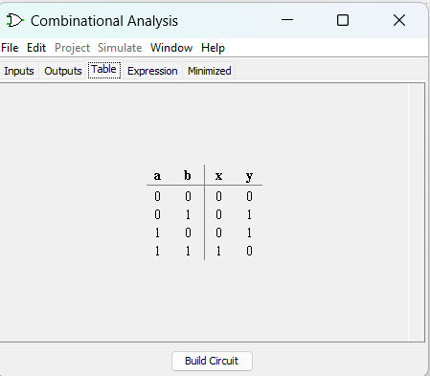

S = A XOR B        C = A AND B

Logical Diagram:

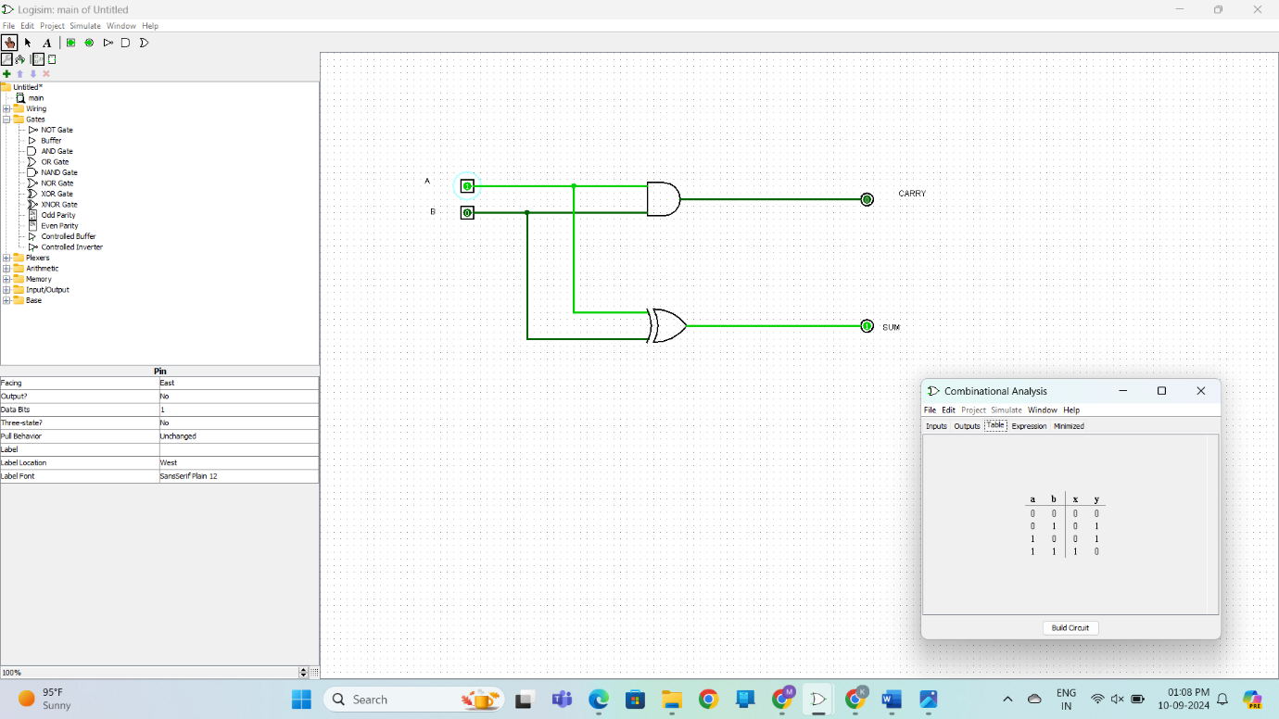

Half Adder using NAND Gates OUTPUT:

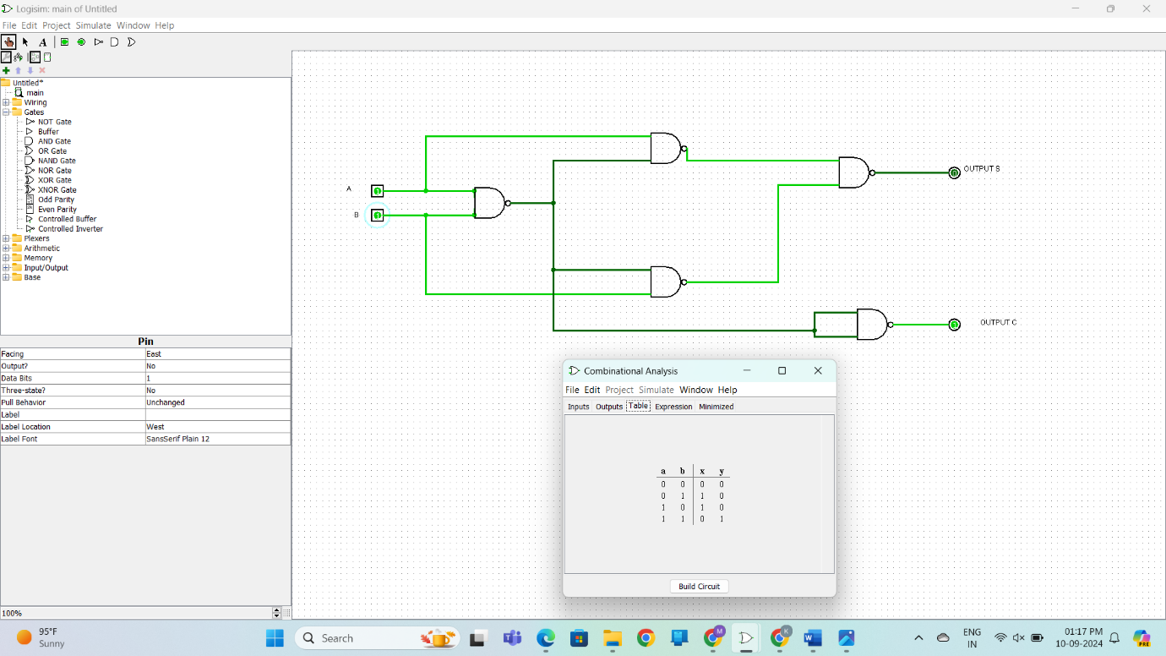

Half Adder using NOR Gates OUTPUT

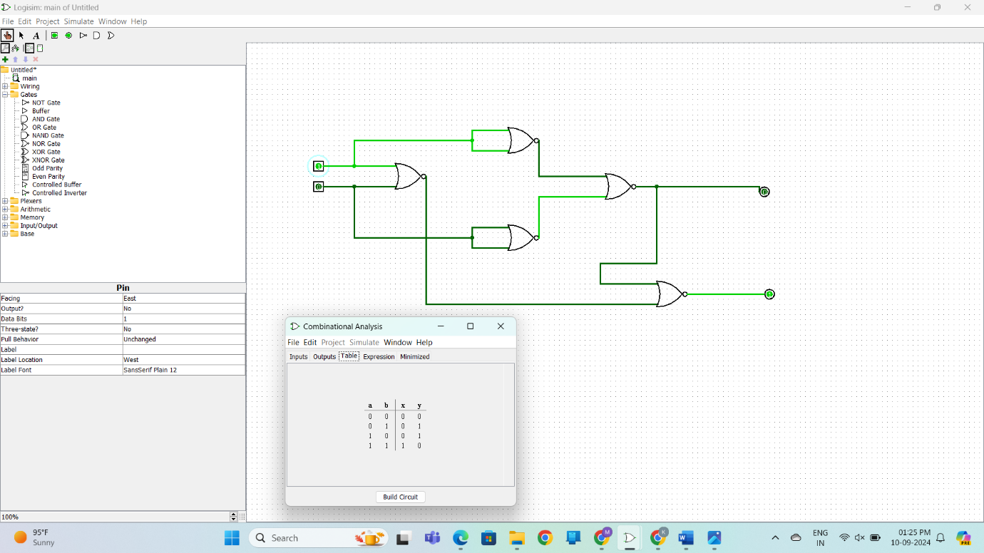

RESULT: Thus 2-bit half adder has been designed and implemented successfully using

logisim simulator.